**Importing S-58 validation results into the Reviewer table**

ENCs created by ArcGIS for Maritime: Charting can be analyzed in third-party validation software to validate the data against S-58. Once the data is validated, the log file can be parsed by the ParseS58LogFile.exe tool to import errors and warnings as records in the Reviewer table.

The ParseS58LogFile.exe tool parses validation log files generated by dKart Inspector 6.x and ENC Analyzer 3.4. Support for dKart Inspector log files is limited to Log File format (*.log). The Verification XML report format (*.xml) is not supported.

**Writing the S-58 validation results to the Reviewer table**

1. Double click ParseS58LogUI.exe.

The Parse S-58 Log File dialog appears

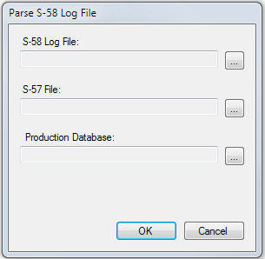

1. For the S-58 Log File parameter, browse to the location of the log file generated by the 3rd party validation software.
2. For the S-57 File, browse to the location of the S-57 cell that was used to generate the 3rd party log file.
3. For the Production Database, browse to the location of the geodatabase, or connection file, that contains the data that was used to generate the S-57 cell.
4. Click OK to run the tool.
5. A Data Reviewer workspace is created in same directory as the S-57 cell.
6. You can now start a reviewer session to resolve the errors and warnings in ArcMap with the resulting data reviewer workspace and the Production Database.

**Starting the Reviewer session and opening the Reviewer table**

Once the validation results are imported into the Reviewer table, you can query, select, modify, and manage these records.

1. Open ArcMap.
2. On the main menu, click Customize > Toolbars > Data Reviewer.
3. Click the Reviewer Session Manager button  on the Data Reviewer toolbar.

The Reviewer Session Manager dialog box appears.

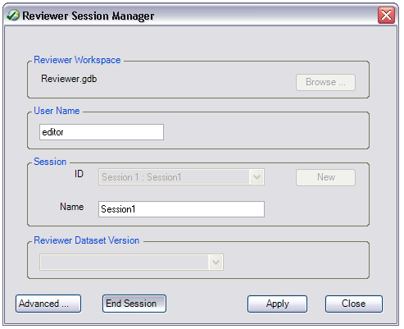

1. Click Browse and browse to the Reviewer workspace that was created by the ParseS58LogFile.exe tool.
2. Click Add.
3. Click the ID drop-down arrow and select the session associated with the validation results you would like to review.
4. Click Start Session.
5. Click Close.
6. Add the necessary Production Database feature classes to the Table Of Contents window.
7. Click the Reviewer Table button  on the Data Reviewer toolbar.

In the Reviewer table, you can zoom to, pan to, select, and evaluate individual errors that have been recorded so that they can be corrected.